Individual Project

Literature review + design

Contents
1. Introductions 4
2. Game Concept and Overview 4
2.1 Game, Level, Character, and systems Overview 4
2.2 Core Concept and Design Vision 4
2.3 Unique Selling Points 4
2.4 Difficulty parameters 4
3. Technical Requirements and Equipment 5
3.1 Hardware Requirements 5
3.2 Software Requirements 5
3.3 Target Platform 5
4. Game Design 5
4.1 Game Objectives 5
4.2 Gameplay Design 5
4.2.1 Game Rules and Structure 5
4.2.2 Player Controls and Camera System 6
4.2.3 Heads-Up Display (HUD) 6
5. Player Design 7
5.1 Player Characters 7
5.2 Player Metrics 7
5.3 Player States 7
5.4 Player Weapons 7
6. Non-Player Characters (NPCs) 7
6.1 NPC Enemies and Allies 7
6.2 NPC & Enemy States 8
6.3 NPC & Enemies Spawning Systems 8
7. Level Design 8
7.1 Procedural generated Level Design Approach 8
7.2 Visual Development 9
7.2.1 Sketches 9
7.2.2 Moodboards 11
7.3 Asset List 11
8. Audio Design 12
9. System Design and Architecture 12
9.1 Algorithm Descriptions 12
9.2 Key Data Structures 12
9.3 System Architecture 13
9.3.1 Structural Diagrams 13
9.3.2 Behavioural Diagrams 13
10. File Management Standards 13
10.1 File Formats and Naming Conventions 13
11. Project Management and Scheduling 13
11.1 Development Plan 13
11.2 Milestones 13

Introductions
This project will consist of a procedurally generated dungeon game which will adapt to the player. It will use graph rewriting where the nodes will represent the room and specific nodes will be rewritten to fit the level. This works into the dynamic difficulty as depending of how the player plays the game the nodes in the next dungeon will cater to the play style making it easier or harder.

Game Concept and Overview

Game, Level, Character, and systems Overview
The game will be a dungeon game where each level will be generated from when you start and every time you finish the dungeon. When you start the dungeon will be fairly basic however once you finish the first dungeon depending on how you do the generation of the next once will be affected with the amount of enemies and enemy type, and the amount of loot rooms.
The character when traversing the dungeon can get items that will increase there attack power and defence.

Core Concept and Design Vision
The game will be a dungeon rogue like where after reaching the end of the dungeon another one is generated which will either be easier or harder depending on how you play. The role of the player is to make its way through the dungeon from point a to b forever in the infinitely generating dungeon collecting loot and becoming more powerful to go further into the dungeon.
The goal of the game is to see how long the player can last as after a bit of playing there will be a point where the dungeon will just start getting harder as they’ll get better loot and other items which will effect the gameplay.

Unique Selling Points
The procedural generation and dynamic difficulty for the game is the unique selling point.

Difficulty parameters
- Enemies health
- Enemies attack power
- Enemies speed
- Enemies Aggression
- The amount of health pack spawns
- The layout of the rooms
- Amount of treasure rooms

Technical Requirements and Equipment

Hardware Requirements
No special hardware is required for the creation of this project except access to a computer.

Software Requirements
- Aseprite – A sprite editing software which will be used for 2D pixel art and animations.
- Unity – Unity as the game engine will allow and easy use of a game editor without having to create one.
- GitHub – Will be used to store the game through and have access to previous versions.
- Visual studio- Twill be used for the programming

Target Platform
The target platform will be for pc players due to mainly focusing on keyboard and mouse support with no intentions of controller’s support. This means features and mechanics made with more variety with the number of inputs and customisation keyboard provides.

Game Design

Game Objectives
The game will have basic objects, for example;
- Defeat the boss and get to the end.
- Find the key and unlock doors
- Defeat enemies in room

Gameplay Design

Game Rules and Structure
The player has to go from the start of the dungeons to the end which will then create a new dungeon. During this process there will be different rooms like enemy rooms, puzzle rooms and loot rooms which will need to be completed to move on to the next.
Puzzles will consist of key and lock puzzles, and switch puzzles. These will open rooms that will be locked with switches being switches you activate and key and lock being you getting a key from another room and using it to unlock the door.

Player Controls and Camera System
The player will have a 8 way movement consisting of north, north east, east ,south east, south, south west, west, and north west.
When it comes to attacking the player will have the option of attacking with there a sword, and bow. They will also be able to roll with a delay between rolls.
The camera will be above the player like a birds eye view, when the player moves the camera will follow the player.

Heads-Up Display (HUD)

The Hud will consist of the players health, number of keys they have, sword, ranged weapon and Armor next to the health.
Rough Mock up 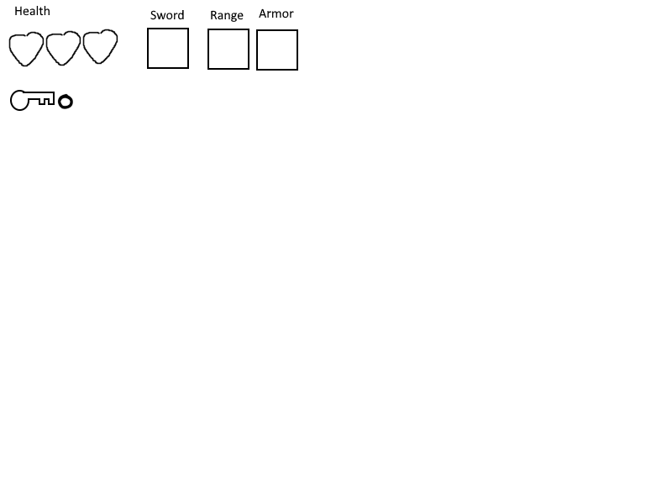

Player Design

Player Characters

Player Metrics
The player will have many different metrics;
- 4 health
- 0 base armor
- One role bar that refills after use

Player States
The player will have different states such as;
- Idle
- Moving
- Attacking Close range
- Attacking long range
- Attacked
- Dead
- Opening chest

Player Weapons
The player will have a good amount of weapons they can find these include.
- Base sword which you start with
- Base bow that you start with
- Long sword which has increased range but is a bit slow
- Short sword which has lest range but is fast
- Boomerang which once thrown comes back to the player hitting enemies twice
- Gun pierces through enemies

Non-Player Characters (NPCs)

NPC Enemies and Allies
Allies
There wont be any allies that follow the player however there will be a merchant room where the player can buy items from them.
Enemies
They’ll be up to 4 enemies at the moment in the game these will consist of ;
- Skeleton that attacks with sword up close to the player
- Bats which are faster then skeletons who need to be close ranged Aswell
- Ghoul that shoots arrows at the player

NPC & Enemy States
Enemy
- Attacking
- Moving
- Dying
- Attacked
Npc
- Idle

NPC & Enemies Spawning Systems
Each room will have a certain amount of enemies in the room depending on the difficulty so it could vary. They’ll mainly spawn randomly in specific spots of the dungeon depending on where the enemy is entering
The merchant will spawn in a stall in merchant rooms.

Level Design

Procedural generated Level Design Approach
When making a dungeon the dungeon the rooms will be randomly selected from a pool of rooms. For example they’ll be many different layouts for enemy rooms that will be chosen when choosing an enemy room.

The game will use a rewritten graph approach when generating the level, the nodes will be rewritten to match a pattern depending on the difficulty. For example if the dungeons set to hard difficulty they’ll be less treasure rooms as they will be rewritten to enemy rooms and for easier difficulties more rooms will become treasure rooms.

Visual Development

Sketches
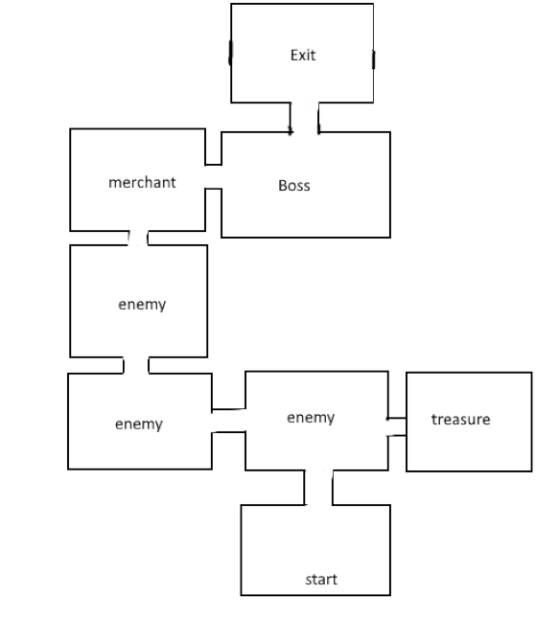
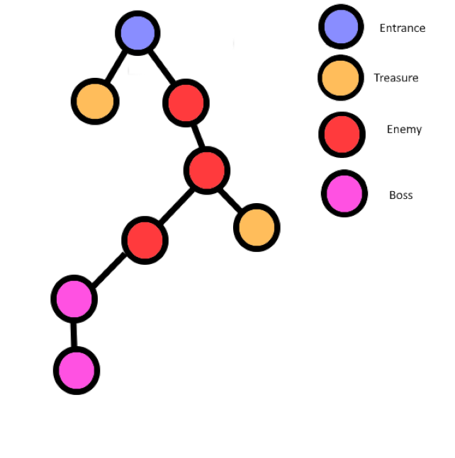

Moodboards
Dungeon
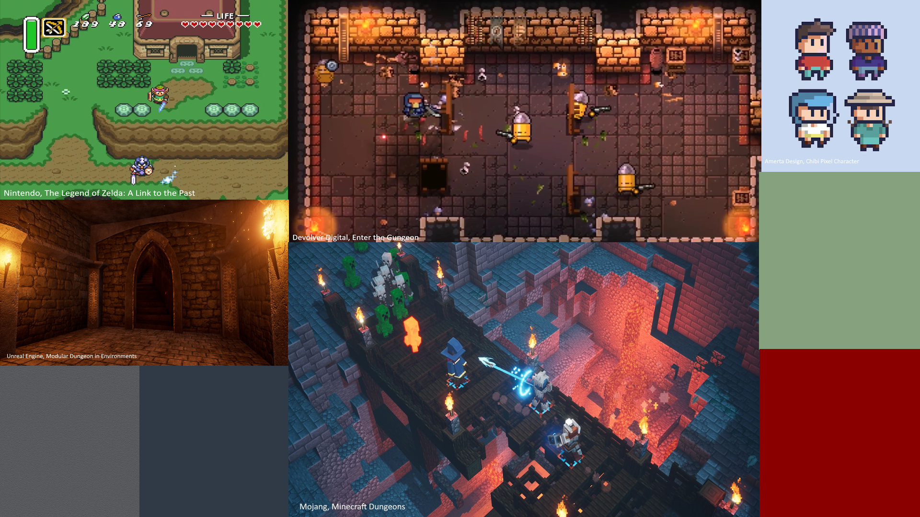

Asset List
- Player
- Skeleton enemy
- Bat enemy
- Ghoul enemy
- Wall
- Variation wall
- Floor
- Sword
- Long sword
- Short sword
- Gun
- Boomerang
- Arrow
- Bullet
- Merchant stall
- merchant

Audio Design

Player
The player will have sound effects for;
- Sword attacking
- Bow attacking
- Footsteps
- Rolling
- Grunts for when attacked
Skeleton
- Bones falling apart
- Attacking sound
- Boney footstep
Bat
- Squeaks noises
- Wings flapping as they move
- Death sound effect

System Design and Architecture

Algorithm Descriptions
With graph rewriting depending of the difficulty the specific rooms will be replaced for example if there is 10 rooms and there’s 1 start room 3 enemy rooms, 4 treasure rooms, 2 rooms for boss, and an exit there will be a parameter set for difficulty that will say how many of a specific room there should be so the like to make it harder there may be 2 rooms. The code will go through the nodes and rewrite the treasure rooms into another room like an enemy room and will repeat until it matches how many there should be.
DDA will be used through a rank system consisting of rank 1 – 10, depending on the players performance this rank will either increase or decrease. There will be separate difficulties that effect the process of this rank for example easy may start at rank 2 and decrease in difficulty faster then increase. This system is used in the resident evil games and uses players metrics to determine the rank.

Key Data Structures

System Architecture

Structural Diagrams

Behavioural Diagrams
Enemies will target the player with attacking in there general direction, this will be done close range and long range.

File Management Standards

File Formats and Naming Conventions
Sprite assets and any other images will use PNGs.
Audio assets will use MP3s.
For file naming each file will have there purpose for example player_sprite.png.

Project Management and Scheduling

Development Plan

Milestones
- Dungeon generation system create
- Multiple potential dungeon rooms created
- Enemies created
- Enemies spawning in dungeon
- Dynamic difficulty implementation

